**Govtech Qn 2**

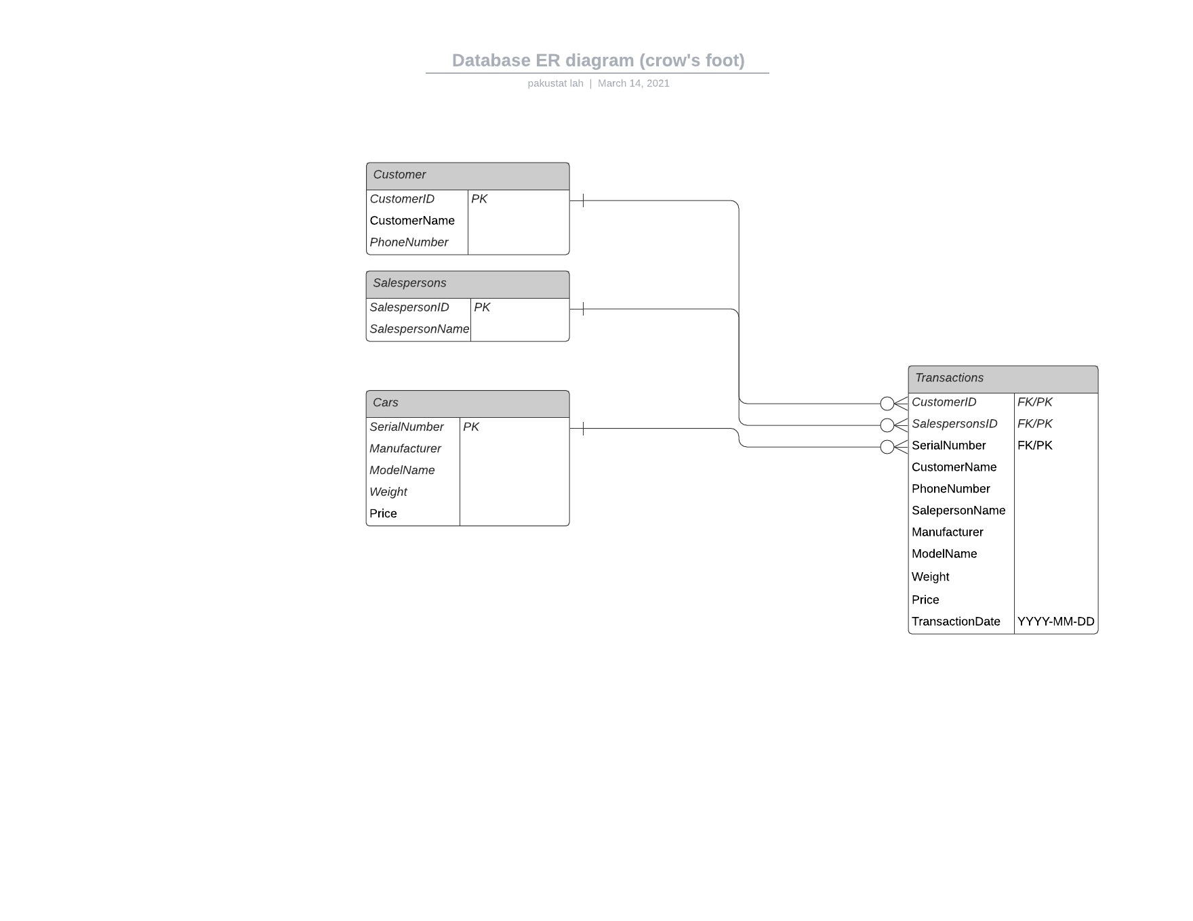

**ERD only to highlight relationship between keys. Non keys do not have errors but the fields in Transactions are old taken from the other tables with the same field names, joined by their respective keys.

**In Transactions table, CustomerID,SalespersonsID,SerialNumber form a composite primary key.

DDLs:

Customer

CREATE TABLE govtech.Customer ,NO FALLBACK ,

NO BEFORE JOURNAL,

NO AFTER JOURNAL,

CHECKSUM = DEFAULT,

DEFAULT MERGEBLOCKRATIO

(

CUSTOMERID INTEGER NOT NULL,

CUSTOMERNAME VARCHAR(100),

PHONENUMBER INTEGER

CONSTRAINT PRIMARY KEY ( CUSTOMERID );

Salespersons

CREATE TABLE govtech.Salespersons ,NO FALLBACK ,

NO BEFORE JOURNAL,

NO AFTER JOURNAL,

CHECKSUM = DEFAULT,

DEFAULT MERGEBLOCKRATIO

(

SALESPERSONID INTEGER NOT NULL,

SALESPERSONNAME VARCHAR(100)

CONSTRAINT PRIMARY KEY ( SALESPERSONID );

Cars

CREATE TABLE govtech.Cars ,NO FALLBACK ,

NO BEFORE JOURNAL,

NO AFTER JOURNAL,

CHECKSUM = DEFAULT,

DEFAULT MERGEBLOCKRATIO

(

SERIALNUMBER VARCHAR(100) NOT NULL,

MANUFACTURER VARCHAR(100),

MODELNAME VARCHAR(100),

WEIGHT INTEGER,

PRICE VARCHAR(100)

CONSTRAINT PRIMARY KEY ( SERIALNUMBER );

Transactions

CREATE TABLE govtech.Transactions ,NO FALLBACK ,

NO BEFORE JOURNAL,

NO AFTER JOURNAL,

CHECKSUM = DEFAULT,

DEFAULT MERGEBLOCKRATIO

(

CUSTOMERID INTEGER NOT NULL,

SALESPERSONID INTEGER NOT NULL,

SERIALNUMBER VARCHAR(100) NOT NULL,

TRANSACTIONDATE DATE FORMAT 'yyyy-mm-dd',

CUSTOMERNAME VARCHAR(100),

PHONENUMBER INTEGER,

SALESPERSONNAME VARCHAR(100),

MANUFACTURER VARCHAR(100),

MODELNAME VARCHAR(100),

WEIGHT INTEGER,

PRICE VARCHAR(100)

CONSTRAINT PRIMARY KEY ( CUSTOMERID, SALESPERSONID, SERIALNUMBER),

FOREIGN KEY (CUSTOMERID) REFERENCES WITH CHECK OPTION govtech.Customer (CUSTOMERID),

FOREIGN KEY (SALESPERSONID) REFERENCES WITH CHECK OPTION govtech.Salespersons (SALESPERSONID),

FOREIGN KEY (SERIALNUMBER) REFERENCES WITH CHECK OPTION govtech.Cars (CUSTOMERID);

SQL queries

1

select customerid,customername,sum(price)

from transactions

group by customerid,customername;

2

select row_number() over (order by quantity desc) as row_num,manufacturer,quantity from (

select manufacturer,count(*) as quantity

from transactions

group by manufacturer) as t1 where row_num <= 3;

3

select manufacturer, count(*)

from transactions

where EXTRACT(month FROM date(transactiondate)) = EXTRACT(month FROM date(current date))

and manufacturer in (

select manufaturer from (

select row_number() over (order by quantity desc) as row_num,manufacturer,quantity from (

select manufacturer,count(*) as quantity

from transactions

group by manufacturer) as t1 where row_num <= 3) as t2)

group by manufacturer;